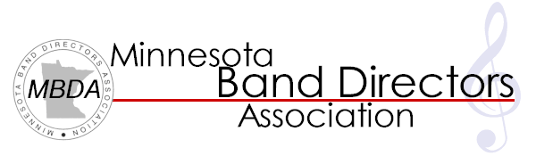
2016 SUMMER
TEACHING SYMPOSIUM
REGISTRATION
Featuring:
- Sam Hazo, clinician
- Chris Gleason, clinician
- The Band Director Band
- Sessions with All-State conductors and opportunities to observe rehearsals
- A chance to meet and socialize with new directors from around the state, an opportunity to discuss teacher evaluations, gain new pedagogical tools and inspiration before you return to the classroom in the fall

August 3, 4 and 5 at Concordia College, Moorhead, MN
Fee: $125 through HB Weekend (April 9/10), after that $150. Collegiate members and mentees contact president@mbda.org for reduced rates!

Registration includes three meals, snacks, participation in Band Director Band, all sessions, and resources from presenters. A list of potential roommates will be sent out in late spring allowing registrants the opportunity to share a hotel room and the cost. Exact times and itinerary will be posted on the MBDA website by May. Detailed information, an itinerary, and Band Director Band music will be emailed to participants in July.

Registration for MBDA 2016 Summer Symposium
Name: _____________________________________________ Phone: _____________________________

Email: ___________________________________________________________________________________

Major Instrument: _______________________ Secondary Instrument(s): ________________________

Do you want to be included on the roommate list? YES NO

Please list food allergies/concerns we should plan for: _____________________________________

Completed registrations and checks can be mailed to: Peter Haberman
MBDA – STS Registration
` 3012 7th Ave N
Moorhead, MN 56560
2016 SUMMER
TEACHING SYMPOSIUM
>Features<

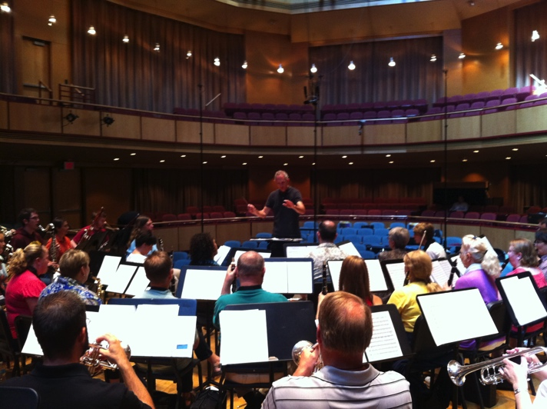

The Band Director Band
Join fellow band directors in creating music in an energetic and rejuvenating setting. Music will be sent during the summer and performed for All State Students. Many attendees mention this as the highlight of the Summer Teaching Symposium

All State Bands
Up close and personal with the All State Bands and Jazz Bands. Observe rehearsals and talk with students, section coaches and conductors

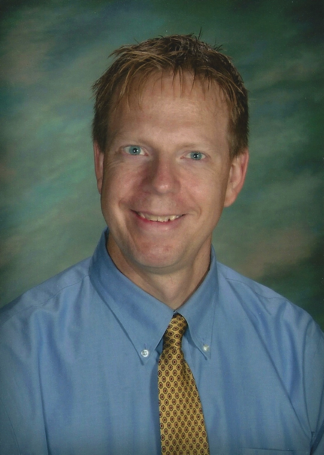
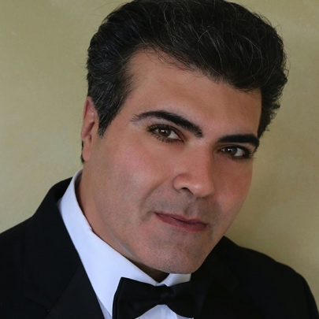
Nationally Recognized Clinicians
This year will include Sam Hazo, Chris Gleason, and the Concert and Jazz Band All-State Conductors.

Debriefings
At the end of each day, gather with band directors from all over the state to talk, share, and discuss… a great way to end each inspiring day!

