Minnesota Band Directors Association Board Meeting
MMEA Mid Winter Clinic
Thursday, February 16, 2012
10:00 am -12:00 pm

I. Call to Order [Charles Weise]
Board members present: Charles Weise, Alicia Neal, Mike Moeller, David Berberick, Tara Michlitsch, Mary Rehaume, Caroline Becker, Brock Duncan, Pam Redlinger, Joni Sutton, Brian Thorstad, John Ginocchio, Greg DeGier, Marcia Thoen, Jim Baxter, Amanda Kaus.
Board members absent: Jan MacDonald, Terri Svec, Adam Tervola Hultberg, Paul Gronert, Bruce Olsen.

A. Welcome
B. Additions to the Agenda: None.

II. Approval of January Meeting Minutes [Brian Thorstad]
Corrections/Additions to minutes: None.
Motion to approve January 14, 2012 minutes made by Mike Moeller, seconded by Tara Michlitsch, motion carried.

III. Reports and Updates
A. Treasurer’s Report [Caroline Becker]
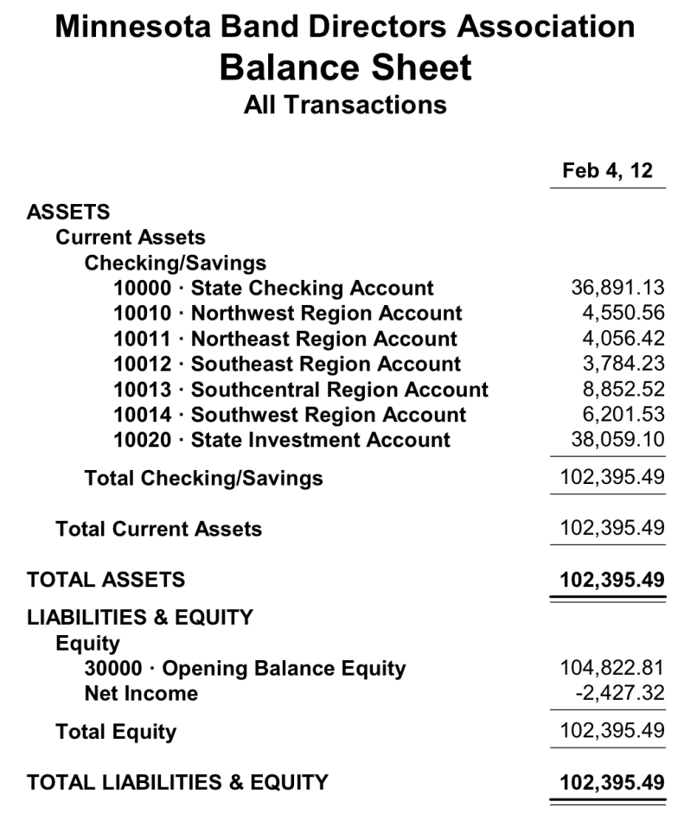

B. Membership Report [Mike Moeller]
Our current MBDA Membership for 2011-2012 is at 314 band directors from all 6 regions. Mike has had a lot of help from Caroline Becker, Sandra, and Charles Weise in continuing to make sure that our membership list is accurate and that all members participating in MBDA festivals are all current on their dues and website registration. Sandra, Caroline, Chuck, and Mike continue to work on a better way to streamline all membership inquiries at both the regional and state level. Work has begun to create a new registration from that will appear on the website for next year’s registration as a PDF for those who continue to pay by check. It will be the same form that is used to fill out the membership info through on-line/Paypal submission as well. A rough draft should be set for the June meeting. Lastly, I continue to work on the statewide database of all schools and their directors, even those that aren’t members currently, so that we have both electronic mail as well as post mail accurate addresses for every band director at every level in every school district in Minnesota.

Discussion was had regarding a change in the MBDA membership timeframe. It was decided that all memberships must be current by Nov. 1st of each year in order to be eligible to submit State Honor Band auditions at the 6-8 and 9-10 levels. Audition materials for the State Honor Bands will be released on August 1st to allow more time for preparation and organization.

C. Region Reports [Region Presidents]
a. CMBDA [Bruce Olson]
CMBDA Honor Bands - Saturday, January 21, 2012 - Elk River HS
6-8 Honor Band Summary:
88 students selected; 25 schools represented; 189 students nominated
9-10 Honor Band Summary:
96 students selected 21 schools represented; 153 students nominated
Highlights:
We had an increase in the number of schools participating. (2011 = 21 schools; 2010 = 14 schools)
Use of a more “in-depth” nomination sheet seemed to improve the quality of
student nominees.
Paul Kile was a fantastic guest conductor.
We had a great turnout (approx. 25 directors) for the afternoon session with Brent Michael Davids.
Dr. John Ginocchio did a great job as our guest conductor.
Suggestions:
Instrumentation would have been better with more Euphoniums
Remind students to mark their parts in pencil.
One piece wasn’t available for Schmitt to purchase and for us to raffle.
Have concert a ½ hour earlier.

I look forward to bringing students to the event in the future, and to being a part of the exciting commissioning project with Brent Michael Davids.
Thank you, Susan Potvin 2012 6-8 Honor Band Coordinator

Reiterating what Susan said, thank you for allowing me to serve CMBDA in this capacity!
Thank you, Brett Krohn 2012 9-10 Honor Band Coordinator

b. NEMBDA [Jan MacDonald]
Our honor band day was a huge success thanks to: our efficient board; outstanding hosts at Duluth East High School (Jerry Upton, Jim Erickson); fine section coaches; well prepared students; and outstanding guest conductors (Dr. Wendy Barden, Osseo and Frederick Nyline, retired Luther College now residing in Sandstone). The concert was well attended. Our program is posted on the website.

The NE region is also getting a Beginning Band Festival off the ground.

c. NWMBDA [Greg DeGier]
NWMBDA held a very successful January Honor Band Festival. Approximately 210 students were in attendance. 19 directors and board members were present. The BFF and 2BF will occur on April 28th.

d. SCMBDA [Marcia Thoen]
Upcoming SCMBDA Events:
6-8 and 9-10 Honor Band Festival is Saturday, February 25, 2012, at Mankato West High School.
Chaired by Brady Krusemark
Guest conductors Dr. Bob Ouren and Dr. Amy Roisum-Foley.

BBF and SYF is Saturday, May 5, at Southview Middle School in Edina.
Chaired by Amanda Kremer.
Pat Kunkel will conduct the SYF and Paul Beck has been invited to conduct the BBF.

e. SEMBDA [Amanda Kaus]
Our Beginning Band and Second Year Band Festivals will take place on Saturday, May 12th, at Park High School (Cottage Grove). Doug Bradley and Eric VanScoy will be serving as our guest conductors. Sara O’Connor is our Coordinator for the event.
Individuals have stepped forward to serve on our Regional Board for 2012-2014 with some board members continuing their service for another term. Names and positions are being finalized.

f. SWMBDA [Brock Duncan]
6-8 Honor Band
Date: January 21st
Location: Marshall High School
Guest Conductor: Douglas Bradley (Lake Middle School – Woodbury, MN)
Host: Carmen Leger (Lakeview HS)
113 students selected

9-10 Honor Band
Date: January 21st
Location: Marshall High School
Guest Conductor: Glen Tuomaala (St. Cloud State University)
Host: Brock Duncan (Benson HS)
85 students

Notes:
We had some difficulty due to the weather.
We decided to change our fee policy for next year. Currently, students/schools pay their $10 registration fee upon arrival at the festival. This has caused a loss of revenue due to “no shows”. The new policy will ask for schools to send one check upon receiving the roster. If registration is not paid, we will move on to other students to fill roster spots. Refunds will only be given if the event is canceled.
Participation was up from last year. We had 325 nominations from 44 directors representing 24 schools. We only have 50 schools in our region. We are happy with 50% of the directors in our region choosing to attend the festival. Our goal is to keep increasing participation.
We are still actively recruiting the empty spots on our board. We are confident they will be filled by the beginning of the school year.

D. April Band Director Workshop [Alicia Neal]
Encourage all you know to sign up! The $10 fee pays for 7 hours of professional development.

E. State Honor Band Audition Report [Tara Michlitsch and Mary Rehaume]
Below are the numbers from the past 3 years of students auditioning. Remember there has been some discussion about numbers based upon hosting the event in the cities vs. outstate, and it doesn't appear so far that it really matters much. That's good news!

The bands have been chosen and the rosters are with Pam as she works on the mailing. We will be there to help her through it.

About 30% of directors chose to submit their auditions online this year. MMEA did the uploading of CDs and the creation of the Excel spreadsheet for us. Mary created hyperlinks to send to directors for judging. MMEA was incredibly helpful in the process, especially with sending out e-mails to dirctors that didn't have 1 - membership, 2 - payment, 3 - student audition forms, 4 - director ranking forms. They made some mistakes, but director error caused a large delay in processing of both CDs and mp3s.

Mary and I had many problems to deal with, some of which she will discuss in a bit. However, we think that in order to proceed with 100% online submissions for next year we need to have a say in how things are organized regarding many things. This year we felt like we were doing a lot of cleaning up of issues that should have never been issues in the first place. The hours spent on this between Mary, myself, and Sandra very easily went into triple digits.

We would like to meet with Sandra, Chuck, and Paul (and anyone else with thoughts) to discuss how this can and should work effortlessly next year. We had judges submit surveys so we will continue to adjust etudes and scales accordingly and will use their feedback on the online adjudicating versus playing CDs.

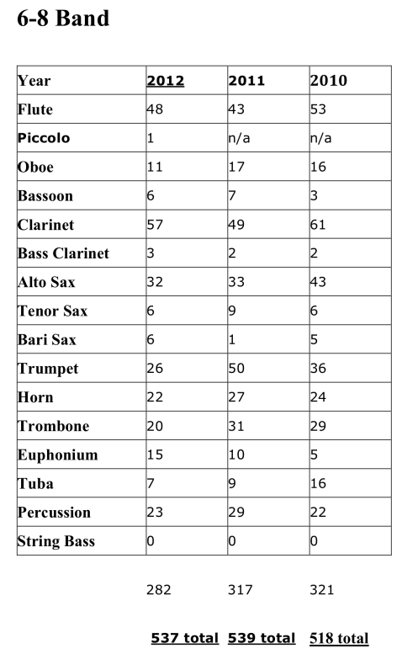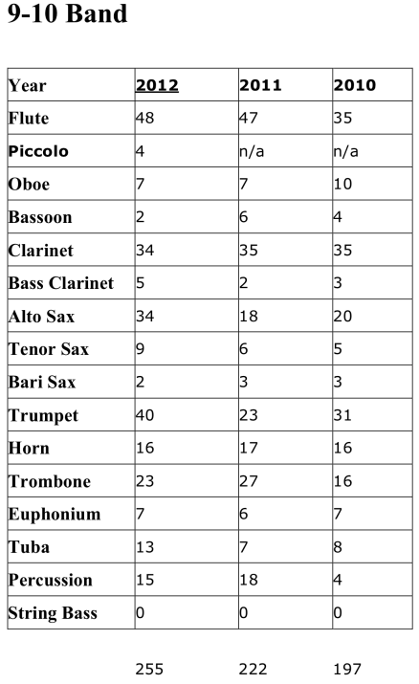

Discussion was had to change the maximum number of students from each school to 8 and the board agreed to try this for next year.

Some discussion occurred about making the clarinet and percussion auditions easier.

Discussion was also had regarding the idea of making videos to help students prepare for state honor band auditions. These videos would be similar to those offered through MacPhail and uploaded to YouTube.

F. State Honor Band Event Report [Pam Redlinger/Paul Gronert]
Honor Band event planning continues to go well. I have materials ready to prepare mailings as soon as I get lists from the audition chairs. Tara and Mary are great to work with.

Packets to directors should include:
Acceptance letter (s)
Decline letter (s)
News release
Schedule
permission/medical form
summary of what they need to bring/reminders
directions with lodging suggestions
letter to director with instructions and deadlines
music
*April Band Directors workshop info (where can I get this?)
Anything else?

Section Coaches Filled:
Flutes 9-10 (Donna Hryniewicki, Mahtomedi)
Saxophones 6-8 (Josh Argall, DGF)
French Horns 6-8 (Denise Pesola, Moorhead)
French Horns 9-10 (Jennifer Larson, Bertha-Hewitt)
Trumpets 9-10 (Dan Carlson, M State, Fergus Falls)
Trombones 6-8 (Olivia Latimer, Moorhead)
Trombones, 9-10 (Tim Johnson, DGF)
Tubas, grade TBD (Doug Neill, Moorhead)
Percussion 6-8 (Jon Dostal, St. Thomas Academy)
Percussion 9-10 (Carvel Kuehn, Rush City)

Section Coaches Pending (waiting response)
Flute 6-8
Clarinets 6-8
Oboe
Saxophone 9-10
Low Reeds
Tuba

Section Coaches needed:
Clarinets 9-10
Oboe
Low Reeds - probably
Trumpets 6-8
A block of 20 hotel rooms is being held at the Fergus Falls AmericInn for directors and section coaches under “MBDA”. Release date is April 1. All are double rooms, per night cost is $89.24.

The percussion needs lists has been forward to Scott K. He will let me know if they need to borrow equipment. I am hoping if he does, we can cover it with the participating schools in the area. A question has come up about mallets. What should the school provide and what should students provide - if any?

Beyond getting mailings ready (date to be determined) other pending items include ordering t-shirts and pencils.

As always, I welcome suggestions from the veterans of this process of any items that may have been overlooked.

G. Mentorship Update [Joni Sutton]
This fall, a partnership was created between the professional fraternity Phi Beta Mu and the Minnesota Band Directors Association. Members of Phi Beta Mu have volunteered to mentor beginning band directors; MBDA board members looked to their Mission Statement, and felt that this project would be a good fit in their mission to assist in the development of band directors and band programs in Minnesota. I have volunteered to spearhead this project, as a liaison between mentors and mentees.

In addition to having information on the MBDA website about this project, I have twice contacted Minnesota college band directors to try to get the word out about this opportunity. Unfortunately, at this point we have but one person who has requested a mentor. This has been set up and has been, according to the mentee, a valuable experience. Somehow, we need to get the word out to newer band directors that this opportunity is available to them. There are information sheets in the MBDA booth in the Exhibit Hall about the project, and the sheets are also being made available at clinic sessions geared for newer teachers. My hope is that, over time, this opportunity will become well known, and that it will grow.

Thinking about MBDA’s mission to assist band directors, perhaps MBDA would also like to consider financial help to new teachers who cannot afford to attend music education/band directing workshops and symposiums that would be helpful for them. I’m thinking about the “Summer Teaching Symposium” or “The Art of Wind Band Teaching” events. MBDA could develop an application process that would accompany becoming a part of the mentorship program. (However, I am not volunteering for this task!)

Another thought I’ve had is that MBDA might consider sending out postcards to all band directors in the state during the first part of the school year, publicizing the organization and its benefits (including the mentorship project) to all band directors, not just current members.

I am honored to be working on a project that I feel so passionately about, and thank MBDA for the opportunity to create this partnership.
Brock Duncan suggested sending this to all superintendents and principals in Minnesota.

Jim Baxter suggested that financial support be provided to and directors in their first three years of teaching or in their first three years of teaching in an entirely new music position to attend the April and Summer events offered by MBDA. Discussion was had regarding this idea.

Motion to support young teachers to attend the Summer Symposium made by Jim Baxter, seconded by Brock Duncan, motion carried.

H. Summer Symposium Report [John Ginocchio]
See attached document for more information.

IV. Old Business
A. Native American Commission Update [Bruce Olsen]
The first check to Brett Michael Davids has been sent and we will have a first draft of the 6-8 piece by the end of March. More information from Bruce Olsen is provided below:
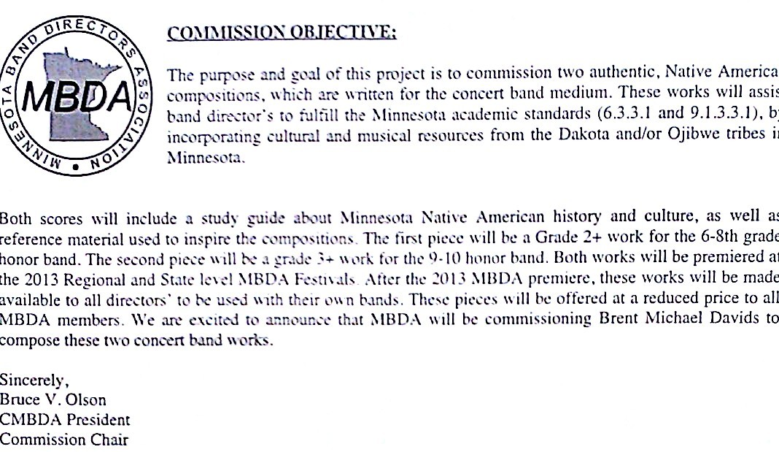

B. Region Financial Structure [Caroline Becker, Jay Lyons, Charles Weise]
A discussion was had regarding the reorganization of our current financial situation with the state organization and region budgets. It is important for tax purposes that MBDA moves all finances to a centralized account. Each region will retain its autonomy, but all finances will be centralized.

Motion to centralize finances for MBDA by closing regional accounts with the understanding that regions will retain financial autonomy made by Mike Moeller, seconded by Brock Duncan, motion carried.

C. College Grants [John Ginocchio]
The Art of Wind Band Teaching hosted at the University of Minnesota – Twin Cities campus and the Minnesota Area Conducting Workshop hosted at Southwest Minnesota State University applied for funds through the MBDA College Grant Program. Discussion was had regarding these events.

Motion to provide $500.00 to each applicant was made by Brock Duncan, seconded by Marcia Thoen, motion carried.

V. New Business
A. State/Regional Leadership [Charles Weise]
A check-in to see make sure all regions are working on finding new board members for next year!

B. Review of Tomorrow’s Meeting [Charles Weise]
The agenda for the general membership meeting of MBDA was discussed.

C. End of the Year Meeting [Charles Weise]
Charles Weise presented the idea of making the end of the year meeting into a banquet that all region and state board members would be invited to. This idea was received well and would be held at Perpich.

D. Remaining Meeting Dates for 2011-2012
Feb. 17, 2012 - MBDA Annual Meeting (2:15 PM)
April 14, 2012 - Honor Band Committee Conference Call (Exec Board)
June 2, 2012 - PCAE - Changing of Regional Officers (10:00-12:30 PM)

VI. Adjournment
Brock Duncan made a motion to adjourn, Greg DeGier seconded, motion carried. The meeting was adjourned at 11:51 AM.

Respectfully submitted,
Brian Thorstad, MBDA Secretary

